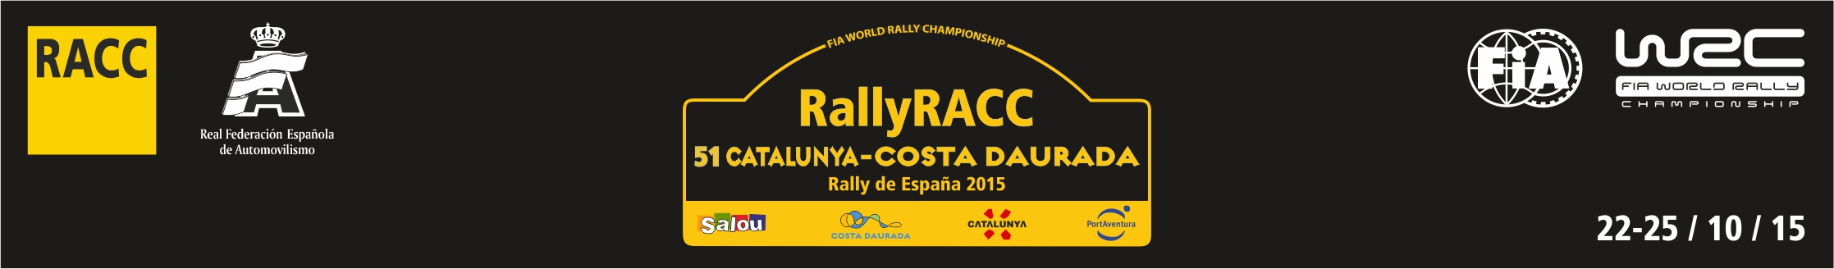

NATIONAL MEDIA ACCREDITATION FORM

- PLEASE USE ONE FORM EACH PASS REQUESTED -

(Por favor usar un formulario por cada pase solicitado)

PUBLICATION / AGENCY/ WEBSITE:
COUNTRY:
ADDRESS:
ZIP CODE: ……………………………CITY: …………………………………………………..……………………….
EMAIL: …………………………………………………………………………………………………………………….
WEBSITE: …………………………………………………………………………………………………………………
TELEPHONE: + TELEFAX: +

DIRECTOR / CHIEF (SPORTS) EDITOR:

CIRCULATION:…………………………… READERSHIP/ WEBSITE VIEWS:……………………………………

DAILY □ WEEKLY □ MONTHLY □ OTHER □

PASS REQUESTED TO ATTEND RALLY:.....................................................................................................

NAME OF REPRESENTATIVE:
1.
TELEPHONE: +.............................................................................................................................
MOBILE: +…………………………………………………………………………………………………………………
EMAIL:
JO □ PH □ JO/PH □ TECH □

NOTE:
JO: a journalist pass gives access to the Rally Media Centre
PH: a photographer pass gives access to the Rally Photographer Area and Rally Media Centre
JO/PH: a journalist/photographer pass gives access to the Rally Photographer Area and to Rally Media Centre and applies only to media representatives who can justify these two tasks.
TECH: a technician pass gives access only to the wiring room.

IN CASE OF EMERGENCY, PLEASE CONTACT (en caso de emergencia contactar con):

NAME:…………………………………RELATIONSHIP:…………………………..CONTACT Nº:………………….

I HAVE READ AND UNDERSTOOD THE FIA ACCREDITATION CRITERIA AND I ATTEST THAT (he leído y comprendido los criterios de la FIA y confirmo que):

- OUR PUBLICATION IS ON SALE TO THE PUBLIC (la publicación está a la venta);

- I HAVE ENCLOSED A FORMAL APPLICATION ON MY AGENCY/PUBLICATION’S OFFICIAL LETTERHEAD, SIGNED BY THE CHIEF EDITOR/SENIOR MEMBER OF EDITORIAL STAFF(adjunto carta con papel oficial de la publicación firmada por el editor o un miembro senior de la redacción);

- OUR AGENCY FULFILLS THE CRITERIA OF CIRCULATION AND QUALITY REQUIRED BY THE FIA (la agencia cumple con los criterios de calidad y circulación requeridos por la FIA);

- I HAVE ENCLOSED A PHOTO (se incluye fotografía tamaño carné);

- I HAVE ENCLOSED A PHOTOCOPY OF MY NATIONAL PRESS CARD (se incluye fotocopia del carné de prensa, si disponible);

- I HAVE ENCLOSED AN ORIGINAL COPY OF THE PUBLICATION (se incluye un original de la publicación);

- I HAVE ENCLOSED PUBLISHED ARTICLES COVERING THE 2014 FIA WORLD RALLY CHAMPIONSHIP (se incluyen fotocopias de los artículos publicados en 2014 sobre el FIA WRC);

- I HAVE ENCLOSED OUR COVERAGE PLANNED FOLLOWING OUR ACCREDITATION TO 2015 RALLYRACC CATALUNYA (se incluye el tipo de cobertura planeado para el RallyRACC Catalunya 2015);

- I HAVE ENCLOSED 15 PUBLISHED PICTURES COVERING THE FIA WRC (se incluyen 15 fotografías publicadas sobre el FIA WRC y dónde fueron publicadas).

Signed:……………………………………………………. Date: …………………………….

Title………………………………………………………..

REQUESTS MUST BE RECEIVED BY EMAIL OR REGISTERED MAIL NO LATER THAN: 23th OF SEPTEMBER 2015 TO:
(La fecha límite para recibir, por email o correo postal, los formularios y la documentación solicitada es: 23 de septiembre de 2015)

RACC PREMSA
ACCREDITATION SERVICE (RALLYRACC CATALUNYA)
EMAIL: lluisa.torras@racc.es

DIAGONAL 687
08028 BARCELONA

APPLICATIONS WHICH ARE LATE, INCOMPLETE, OR SENT BY FAX MAY NOT BE CONSIDERED

(Las solicitudes que lleguen incompletas o fuera de plazo pueden ser denegadas)

